Guide to writing to your MP
Why should I write to my MP?
Your MP is there to represent you in Parliament and respond to your concerns. Writing to or emailing your MP can bring attention to your concerns about the rising cost of living and encourage them to act on your behalf. The more people who raise a concern, the more likely an MP is to act.
Who is my MP?
You can find the name and contact details of your local MP here: Find MPs - MPs and Lords - UK Parliament
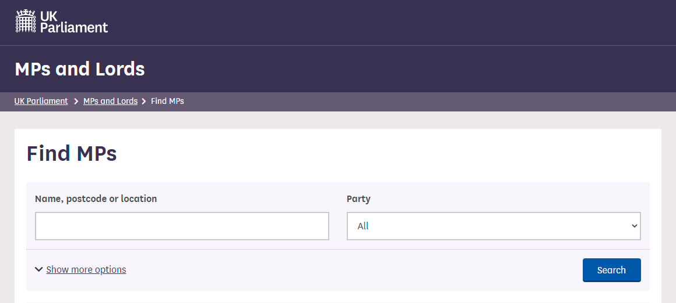
How do I contact them?
You can either send an email or a letter via the post. All contact details can be found online.
What can my MP do?
There are certain things that all MPs can do on behalf of their constituents:
- Ask questions in Parliament which will go to the relevant Government Minister
- Write or talk to a Minister to share the concerns that you have raised
- Raise points in debates in Parliament
Some MPs will have positions in Government or the Opposition or sit on Committees which give them additional opportunities to influence change.
What should I say?
We’ve included a template below showing how to structure your letter, but the important bit is sharing why this issue is important to you and what your experiences are. When writing about how the rising cost of living is affecting you, you might want to think about your answers to the following questions:
- What changes have you had to make due to the rising cost of living?
- How has this affected your wellbeing (emotional, mental, physical etc.)?
- How are you feeling about the future?
- How easy have you found it to get support?
What would you like your MP to do to help?
It’s important that you include your address and postcode in your letter or email as MPs will generally only respond to their constituents.
Template
Dear <<MP name>>
My name is <<your name>> and I am a constituent of <<your constituency>>.
I am writing to you to share how the cost of living crisis is affecting me and my family. <<Your experience>>
Please support me and my family by calling on Government to: [delete as appropriate or add your own]
- Review rates of Universal Credit and other benefits to keep pace with the rising cost of living
- Ensure that local authority funding is made easily available to support families when they need it
- Provide targeted financial support with the rising cost of living for families in need
I look forward to hearing your response.
Yours sincerely,
<<Name>>
<<Address including postcode>>

