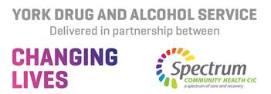
Young People’s Substance Misuse Referral Form
Please email completed forms to york@changing-lives.org.uk
or our secure email is blossomstreet.admin@changinglives.cjsm.net
First Name: Surname:
Referrer Details
Date of Referral:
Service: Position:
Email Address: Contact Number:
Young Person’s Details

First Name: Surname:
Date of Birth: Age: Gender:
Young Person’s Contact Number:

Address : Postcode:
Has the young person consented to this referral? (Please Circle) YES NO
Has the parent/carer consented to this referral? (Please Circle) YES NO
Initial contact will be made direct with the young person. If you wish to discuss the referral prior to us making contact, please call our office on 01904 464680

Please Provide Any Risk Information

 | Substance | Frequency | Amount | Method | Age of first use
Main Substance
Substance 2
Substance 3
Please give brief details of the reason for referral/presenting issues?

Substance Use

Are there any other agencies providing support to the Young Person?
YJS CAMHS SOCIAL SERVICES OTHER
Please provide details:

Any physical/mental health/communication/support needs? If yes, please state:

